Green Sky prep:

5 things your responsibility on daily basis:

1. Take the latest code from git for work with latest code.
2. Before I push the code in repository, my other tem leads will do code review
3. Meeting with QA peoples for defect quick meeting.
4. Standup call for status
5. Hrs and status taks status change in rally/jira

Who I am?

As I have worked 13 years in UI development, so I can work as a Sr. UI developer/Team lead, I can lead to junior developers for best practices. So app should not performance related issue in future.

Expectations:

I am looking for good environment of work, which have latest technologies. So I can enhance my self. Like ang 2 and es5.

If my skills differs:

I can get ready in 48 hrs for any new skill set for start working, that should not be problem. I moved from .Net to web technology in 1 month. Totally change javascript, css, html, backbone, less, grunt.

Angular 2.0

Why need type script ?

We use type script, because after compile and build, it will create .js file and while doing it it will compile your code and throw the errors. Earlier if we use to write the in JavaScript, it use to run and through the error run time and app will crash.

That concept is same as .Net/Java.

You can not deploy the code if there are errors.

tsLint : This finds the errors in editor and suggest code with dot,

TypeScript editor: visual studio core

We can add addOn into VSCode, that will be very fast.

Angular have class concept and can do all the inheritance. Main things

Four things are major in angular 2.0

1. Module
2. Components
3. Pipes
4. Services

Module: suppose we need to create app, and one module is searching and editing, and viewing.

We can have three different modules and each module can have multiple components.

One component can connect to another component,

Ex. We created on pop-up and that pop-up have cancel and OK button and have some text, and now another module can use this component in different module.

If we wanted to add another component for cancel button action, you can have it.

So One module will have multiple component.

If another person want to use my component so he should not connect direct one component to another component, if I have M1 component and C1,C2 component , that I need to export whatever I wanted to share in my module, so other person can have export in their module M2 and then by M2, C1 can be use in in M2 module.

That is best practice.

But we wanted do export/import directly component then what will happen , whole code will be written at build time on top of file and build size will increase ,if we are doing like everywhere in our application then build size move very big.

So export/import module.

Reason is it have reference only, it will not have whole bunch of code.

Component will always joint with module.

Pipes:

If you wanted to have small calculation then use pipes, usually programmer write code in same file to use it, but in angular you can have separate file for pipes and small business logic, that will help to do unit testing. After doing this all core concept will have in separate file and 95% chance is not break application in PR.

Above are also best practices.

Then HTML will be smooth, no if condition needs to use in DOM, otherwise app can be slow due DOM heavy.

Services: Services can have only data.

Ex. Object it will have, like name, id, and address and with data.

For getting the service call, we should create service component. And do restful call and fill service object with data. Pass URL and input and if you wanted modify the data by pipes.

If we need to store the for common pupose then store in service otherwise if data is getting expire immediately then have in local var.

With this all four whole app can be crated

Bindings:

Two binding: sent a data from component to view and changes happening from both side. By [()]

We can do by $event.target

On way binding: display the data in view by component and its not changing. By []

We have multiple way to take data from view to component

1. [()]
2. events : keyup keydoun
3. ngChange = fun($event), we can get event
4. (click) angular way
5. form after submit form
6. ngModel , with variable

we can use events by angular 2 concept it works smooth, if use onclick the it will be javascript way. That’s old way it not recommended.

Component sharing”

One module M1 has 10 components

Export 6 class for others, 4 classes or component are abstracted mode, no one can use it, that’s call OOPS concepts.

M2 can use only 6 classes by import keywords .

Overriding:

M1 have Data component and also M2 have same name Data component and both needs to be obstructed Data component.

Build process can be done by webPack, this the best way to do packaging or build.

It will create three files, **js, html, .css**

**Digest cycle for Angular**

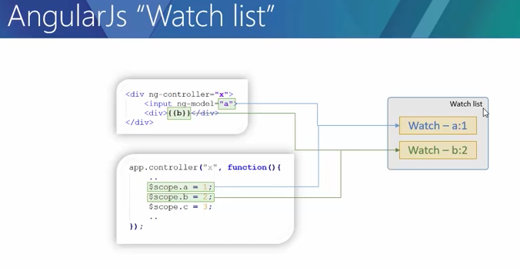

All watcher have list which is reference of all watchers.

* All the data bindings are monitor byy watch list of watchers.

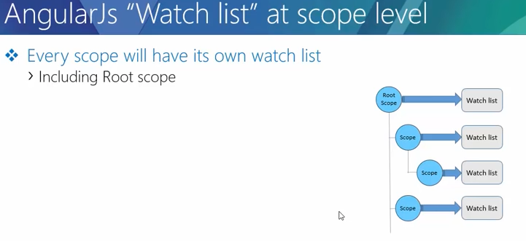

Each scope will have sepearte watch list.

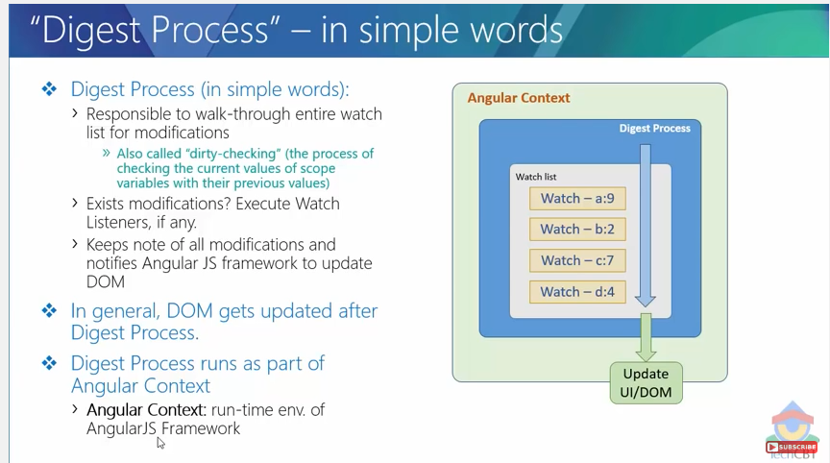

Watch and watch listener

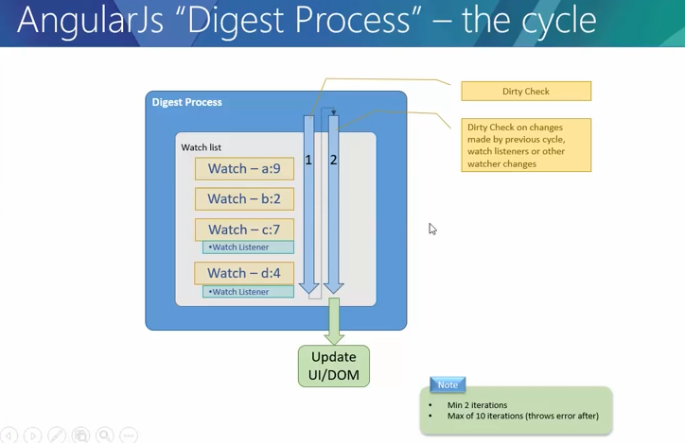

In below picture

Note : Digest cycle always do minimum iteration two times.

1. by controller 2nd watch b’s value got change , now digest cycle will do dirty checking and again double in next everything looks ok or not. Anf update the DOM.
2. In second example , watch C have $watch listener and got change value c:7 (previous could be 6 or so), and $watch will do change value of watch b’s value 2 to 3, then first digest cycle will note $watch change value second digest cycle will not watch b’s value and 3rd time will check again everything looks ok or not.

So max no 10 for digest cycle iteration, if after 10itaration, digest cycle will though the error.

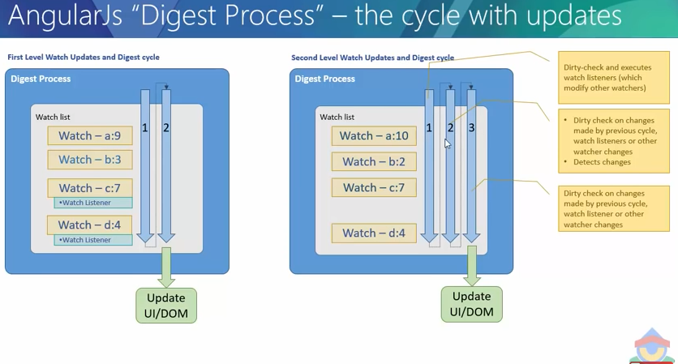

**Example :**

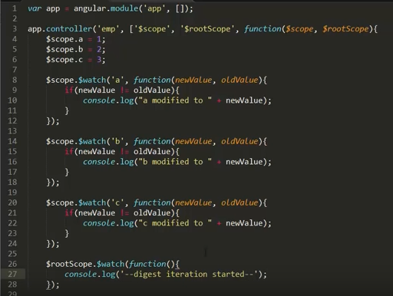

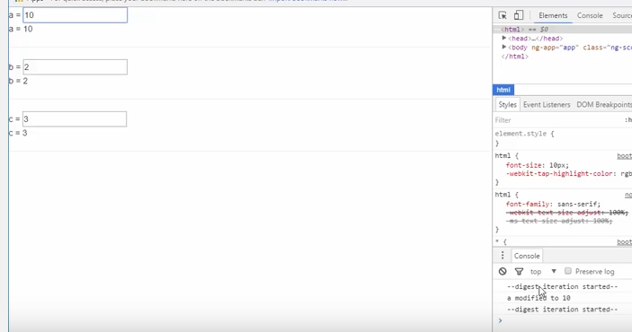

Variable a, 1 change to 10, first cycle have notes second is done for making sure, see in console.

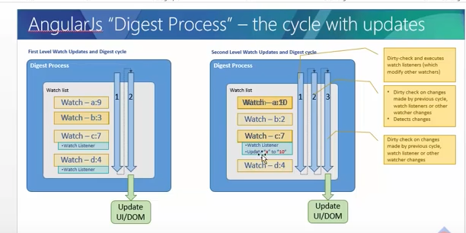

**in the example**

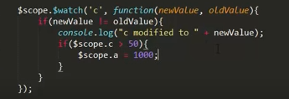

**$watch is changing value of different watch. So cycle will happen 3 times in console.**

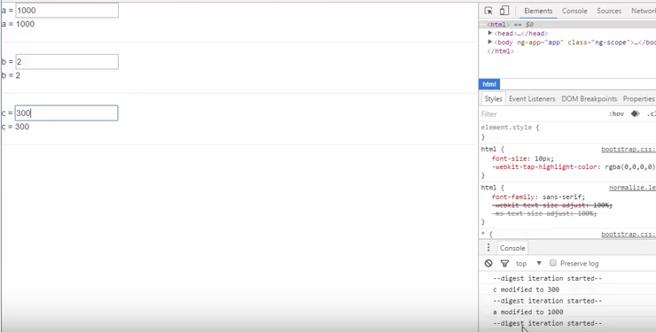

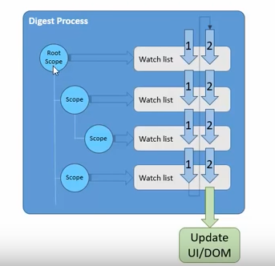

* **digest cycle will start from $rootScope and goes to $scope watch list.**

**- check if any watch list have any change required.**

* In the Angular context we have yellow bridges for digest cycle to start or kick on,
* if we are not configuring from browser native to bridges , digest cycle will not start. , Below all five bridges are responsible to start digest cycle.

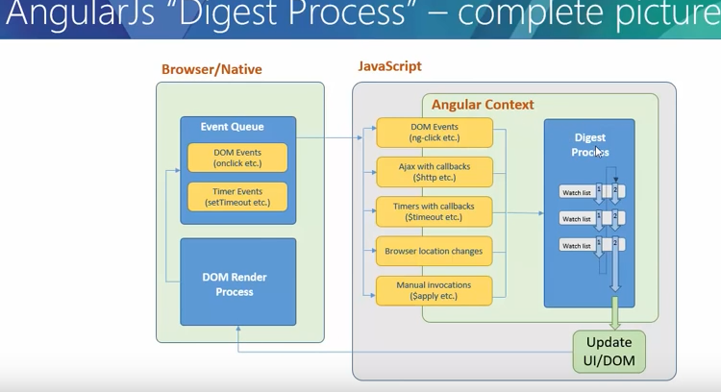

**Digest cycle vs. apply in depth**

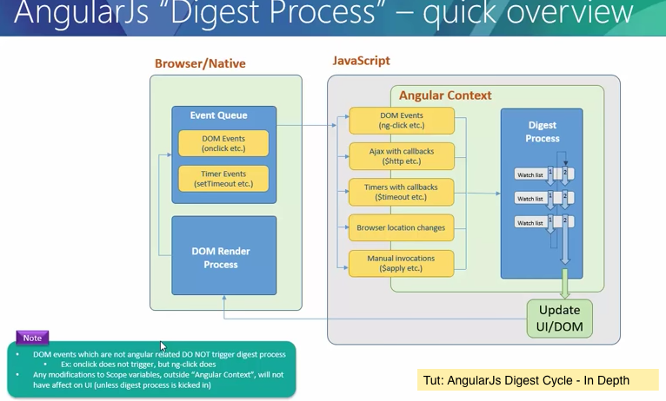

1. if we have onClick in native browser written in javaScript, then Angular context don’t care about any events which are out side of angular context.
2. UI will be getting updated by Angular context to DOM/Ui update as in picture.

Next slide :

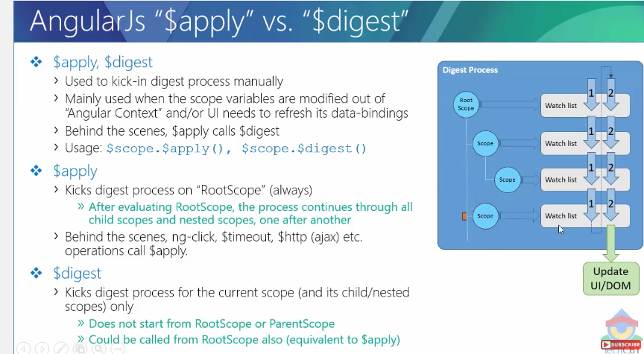

1. whenever you use $apply, it will start from rootScope and goes to child scope.
2. Whether you call $apply or not, ng-click,$timeout,ajax call back, will automatically call $apply after end of their logic internally and $apply will invoke $digest.
3. That is the reason in above picture in yellow under angular context (ng-click,Ajax - $http, $timeout, bowser location change ), digest cycle kicked on.
4. $digest() – it start from current scope , not from rootScope. It improves your performance in SPA. Whenever you have too many no of scope, and you don’t want to touch other scope wanted go for current scope, need to use $digest. Also it will go through it’s children scope also but decently from rootScope.
5. If you are doing $scope.apply() and $rootScope.digest(). Both are almost similar.

Example :

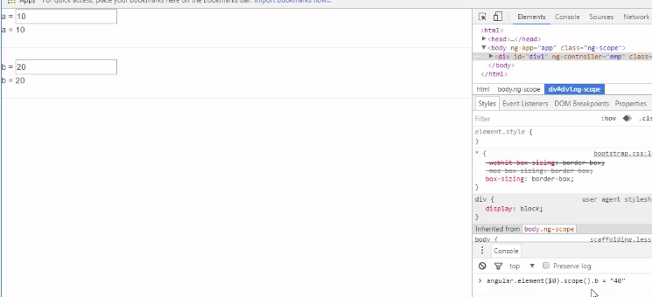

1. here we have used $0, that’s chrome function, it give first element of your DOM. (make sure you highlight node in HTML then only $0 will work)
2. Angular.element($0).scope().b=’40’, this is changing the value from outside of Angular context, if you see in side node , you will see 40 value is updated in DOM but not rendered in UI. It due to digest process doesn’t now it has to kicked –in.
3. In this setuation , we can stat diest cycle manually by angular.element($0).scope.apply(), it will start kick in digest cycle and value will be updated.

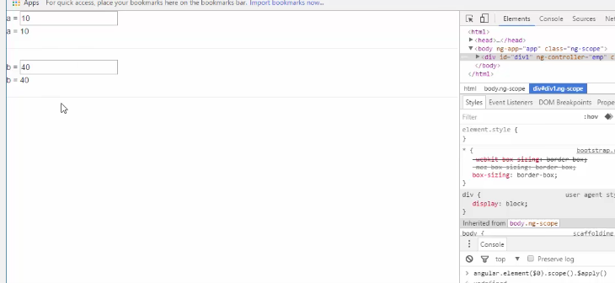

1. if you have click event to sho these value then updated values because ckick event start digest cycle.

Example to use side of angular context , and using $apply.

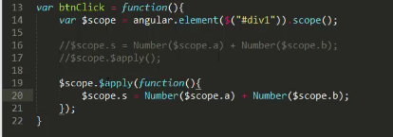

$digest explanation :

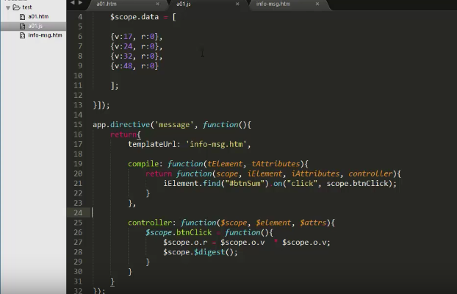

1. here are playing both each object , each object have rendering by directive , buttons and data and calculation.
2. So if change value from out side of angular context. Ex in console or in by javascript.
3. And say $scope.apply(), all objects data will be refresh due it start from $rootScope and goes to all child ‘s scope
4. But you use $scope.digest(), it will be separe of each object , it means each scope of object will have own control of digest cycle to run. It improves performance in Angular app.

**Scope inheritance**

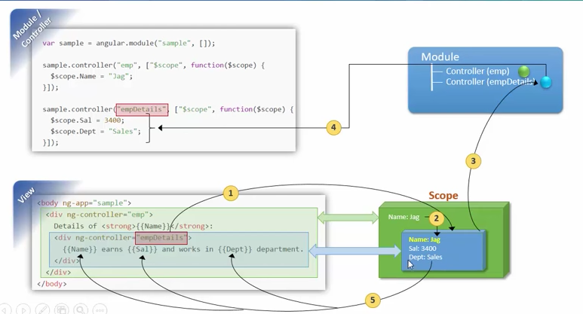

1. emp controller’s all properties will inherited into empDetails controller , that will be child scope of emp’s. as per above picture.
2. If same name property have parent and child both, then child will override the parent property in child scope. Always child scope will take precedence.
3. When you see child scope object in console, internally inherited objected you will see inside __proto__ and id also.

**Rootscope and scope inheritance**

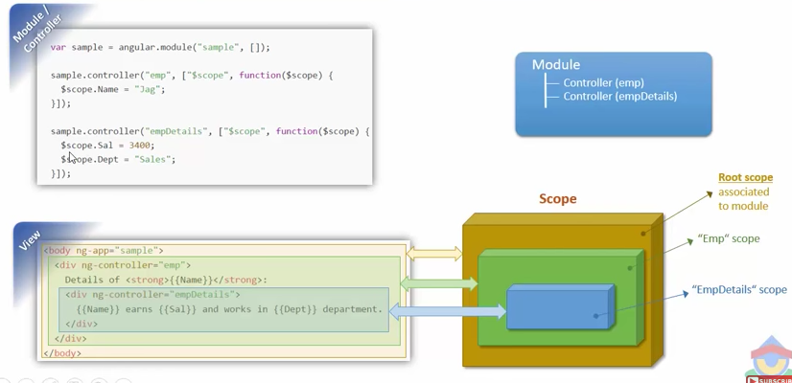

**Having rootScope and run function in below picture**

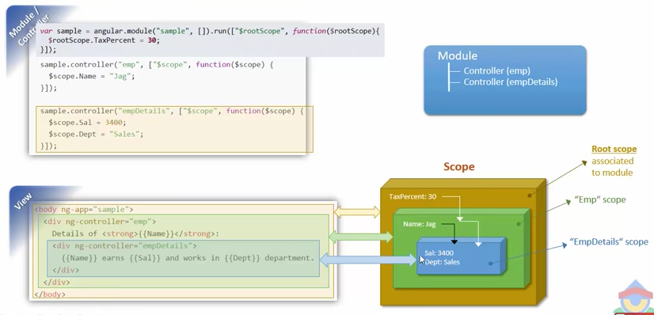

1. **rootScope will be inherited in all the Childs and nested Childs,**
2. **if any child controller change the value of rootScope, then it will be reflected in all the controllers , controller is using referring value from rootScope not copying.**
3. **Its not good practice for sharing the data, if nothing is working for you.**

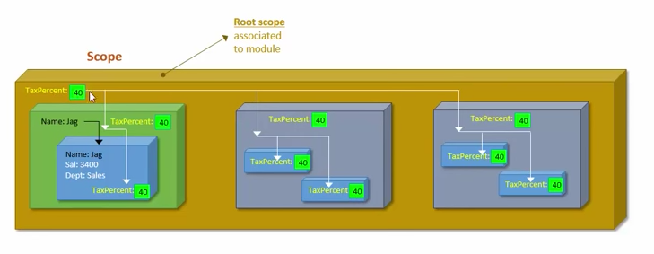

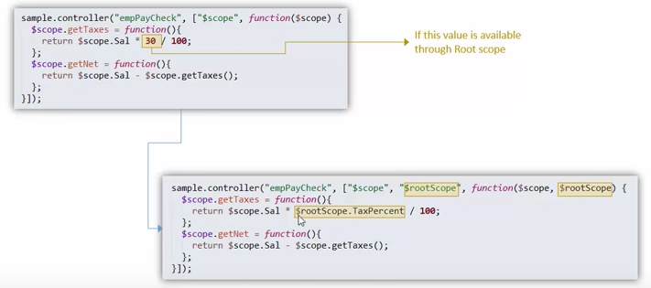

**Services vs. factories**

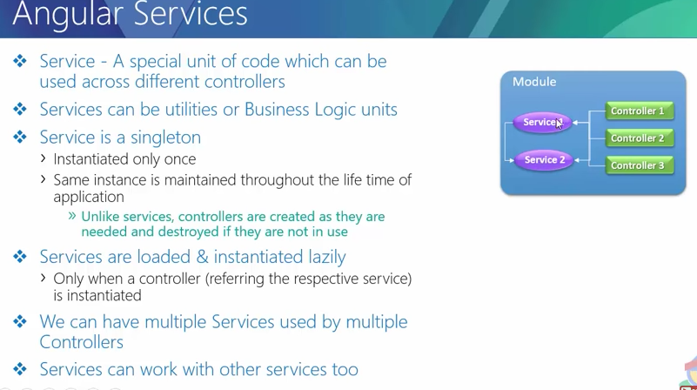

Factory : This have empty object and return object with associated all the function

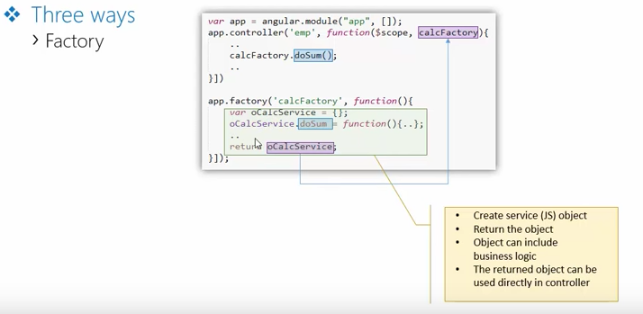

Services : you have method directly associated with this object as same as controller

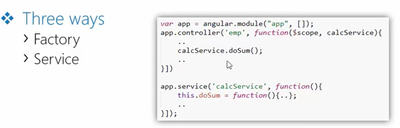

**Factory vs. service :**

1. in the factory you create object and return to controller , in otherway its our responsibility to create object and return .
2. In service, you don’t create object , you just create method with this object , angular framework take to create object while injection.

**Provider:**

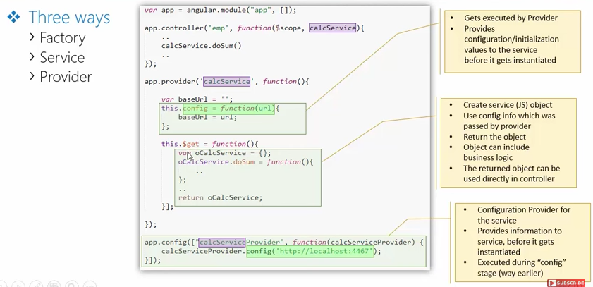

**Compile in directive in depth:**

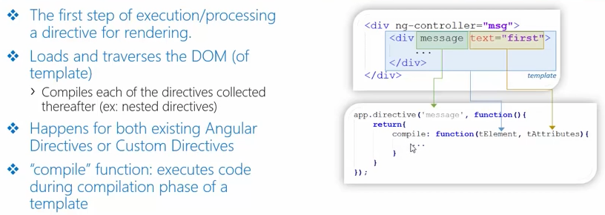

We have optional functional ‘compile’ that have two parameter in args.

1. tElement : that will be you whole html template where you are using your directive.
2. tAttr : that array will come whatever attributes you used in template.
3. Whenever directive is getting executed , it complies only once, it very important to remember .

After compilation, the same template is getting created instantiated and below operation happen:

1. controller : It is getting executed
2. Pre linking
3. Post Linking

DOM will be able to rendered until unless, link phase has been executed.

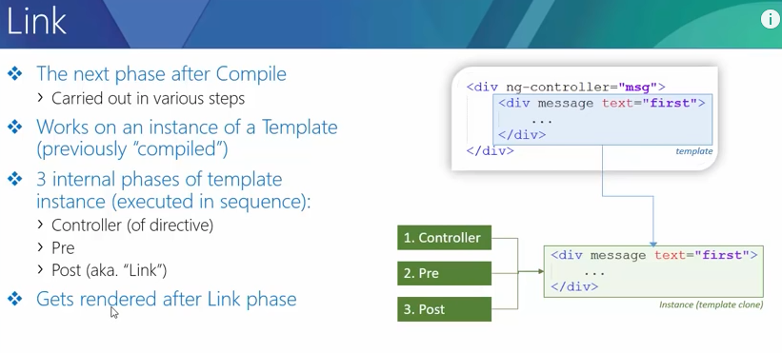

Compile and link process :

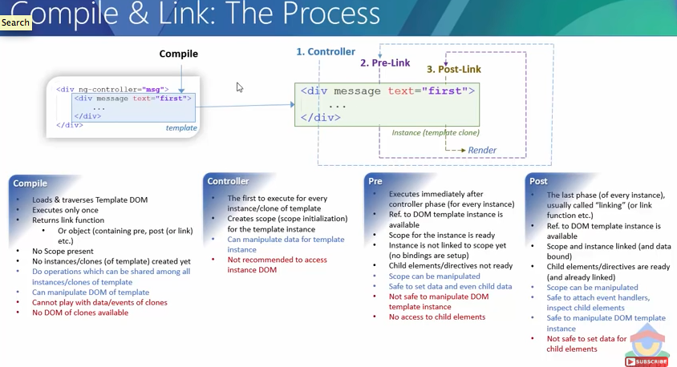

Nested directive compilation and linking

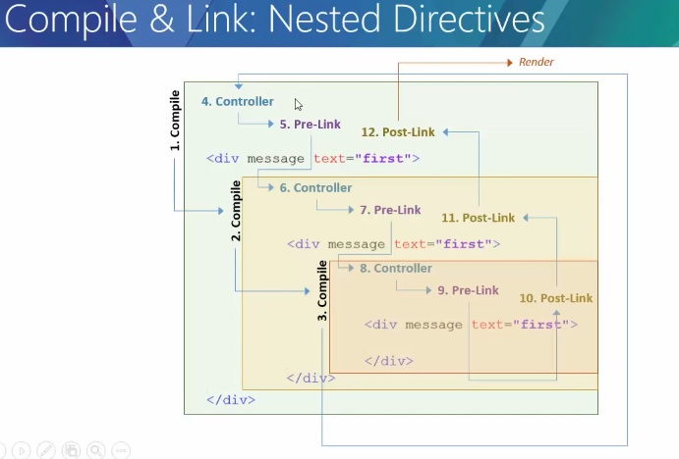

Example of pre post linking

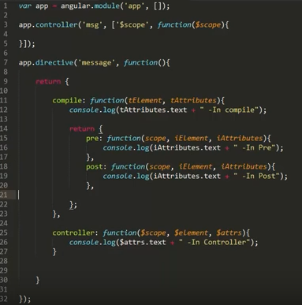

**output**

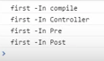

**Nested directive for pre and post linking**

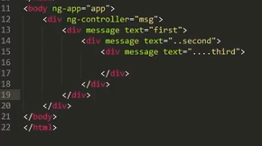

Output

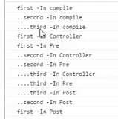

**NG-REPEAT in directive and compile,controller,pre.post**

1. {{ i}} is not evaluating because its compiling and compilation time there is no scope available .
2. its compile only one time , even though there are 5 instance of template in DOM, if there are nested directive then each template will compile every time.
3. See in controller also we see {{i}}, its because we are using attributes.text, if we use $scope.text, then we can get original value, because controller have $scope access .

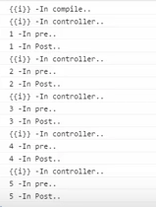

1. if we really needs to evaluate {{i}} in controller then need to $interpolate service to evaluate string/text, see in controller function.

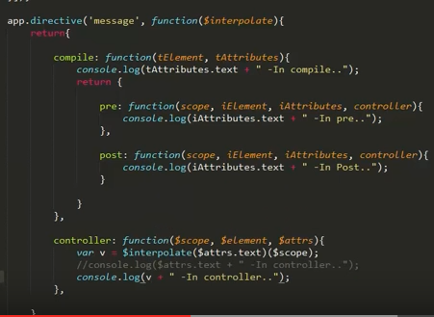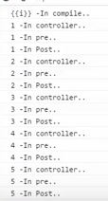

**Modify DOM and attach event in DOM:**

1. added btnClick function inside the controller and have added listener in post function for iEliment.

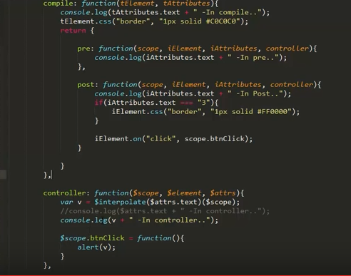

Shortcut for not using compile function, instead use link function, actually compile return link object after compilation. And link will have pre and post function to use it.

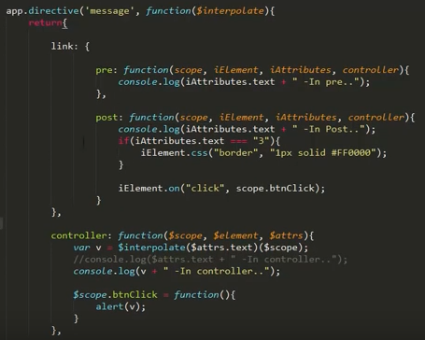

Another shortcut , another way to not use pre link function and use compile and post. If we use only post then no need to write post method name, just return the function inside compile function.

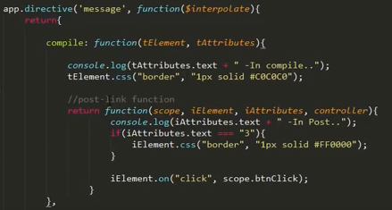

if we search sample code in internet, we can find some kind of below example.

If we don’t need compile, pre, controller, just wanted some DOM manipulation by directive.

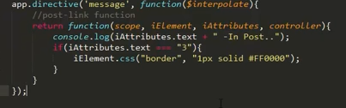

Watch in angular

1. Depends on anguar framework, to which variable it needs to watch or not.
2. If $scope.a ,$scope.b is there in controller , and {{}a} {{b}} also have binding in DOM then only two watch will be there in digest process, otherwise not.

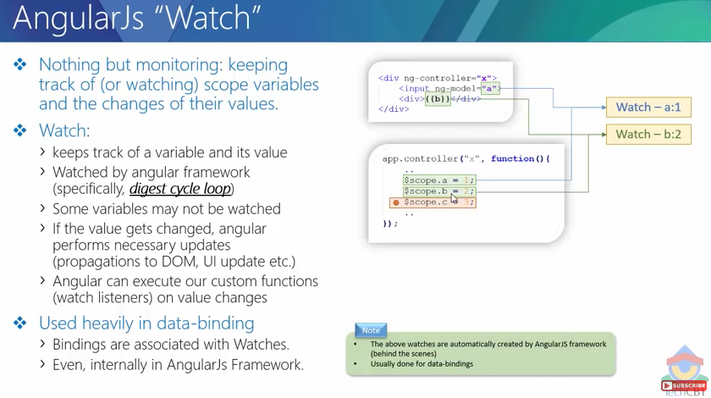

**How many watcher needs to have in your app.**

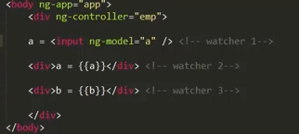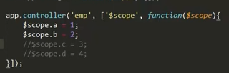

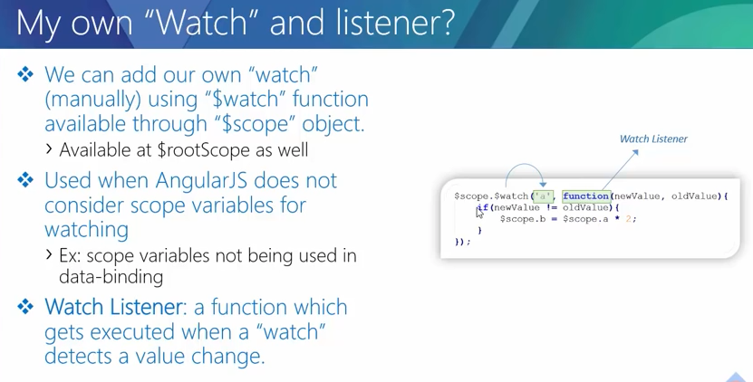

**$watch – reference watch**

* it is watch variable name ‘a’ or whatever name you have. But if you have object Ex. var o = {a:1,b:2,c:3}, this object o will be reference watch and if any value change in a,b,c , $watch is not going to execute.

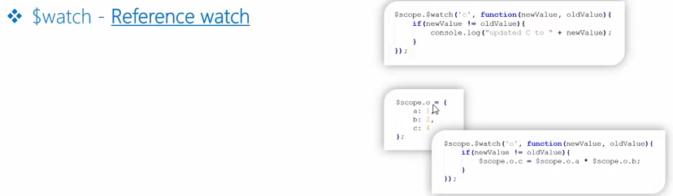

**$watch with “true“ equality watch**

if we add true variable in third parameter in $watch function, then $watch will go in depth and verify all the inside variables.

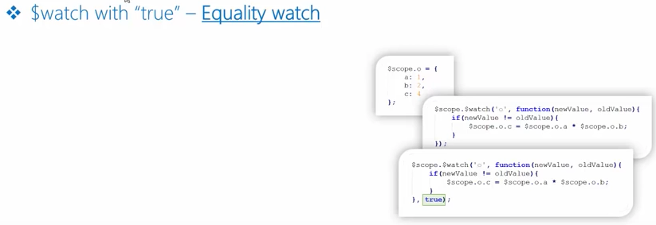

$watchGroup – reference variable for multiple variable

* you don’t need to write separate two function for watching two variable.
* wtachGroup does not support equality watch ,make sure don’t forget this.

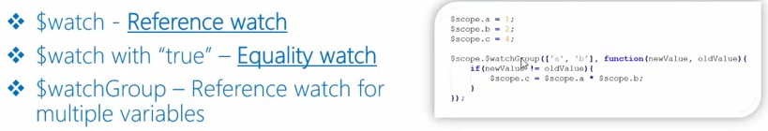

**$watchColection – Collection watch**

* Collection watch works if array is got modified by push delete join , all kind of array functions.
* If Arrays property got modified, then this is not going to execute, then use equality watch. In angular language , we call deep watch to equality watch.

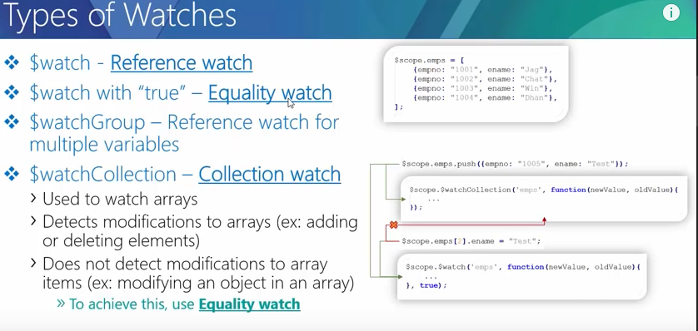

**Demo**

Always remember ng-change will not create watch , it is associated with ng-model.

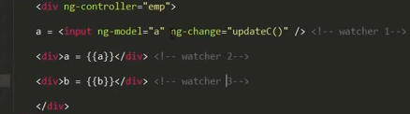 , 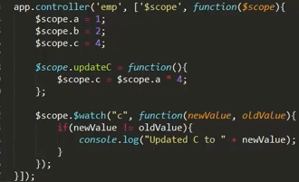

result :

you can see by angular watcher , we have four watcher and c got changes as well .

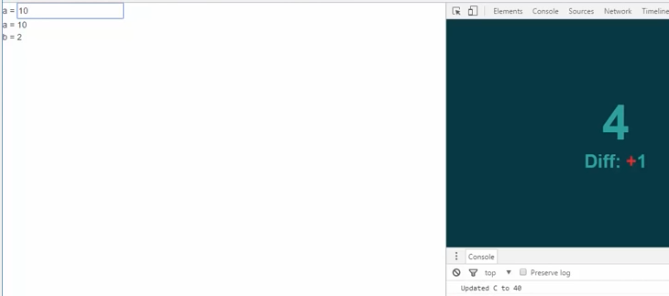

**watch collections example :**

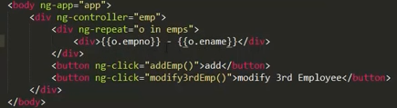

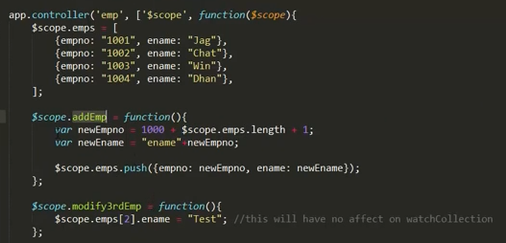

watch will same as ng-repeat will have count of object inside, if array length is 100, then watch count will be 100.

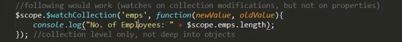

watch collection fire only if delete add, new enter in array , if you directly access any element and change value , this will not going to , if wanted to do that use $watch with third parameter true, that’s called deep watch or equality watch .

What is Shared Scope (in Directives)

If we have custom directive and uses in under parent controller, it will use same scope , which was from parent. See the ex. below .

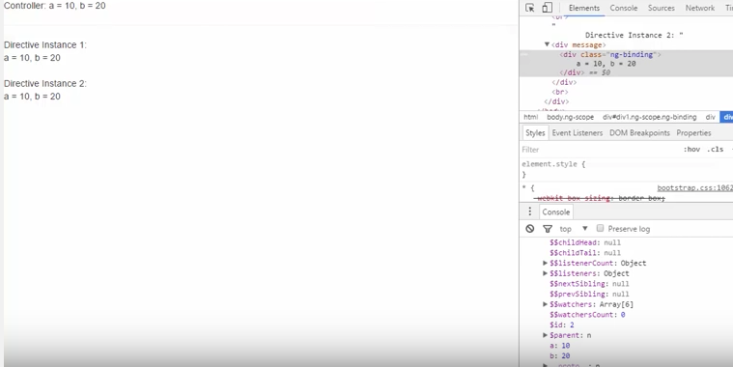

here we are inspecting 3rd element of directive and shows same id which h has parent. See the DOM.

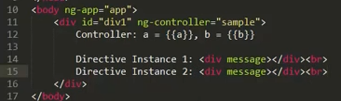

if you have controller’s method inside directive ‘valueChangeB’and have in parent controller also, always directive method will take precedence.

**Isolated scope in directive in depth**

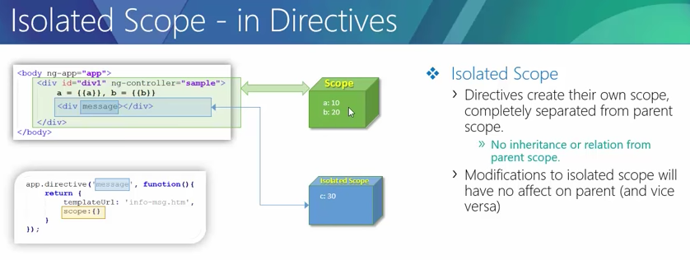

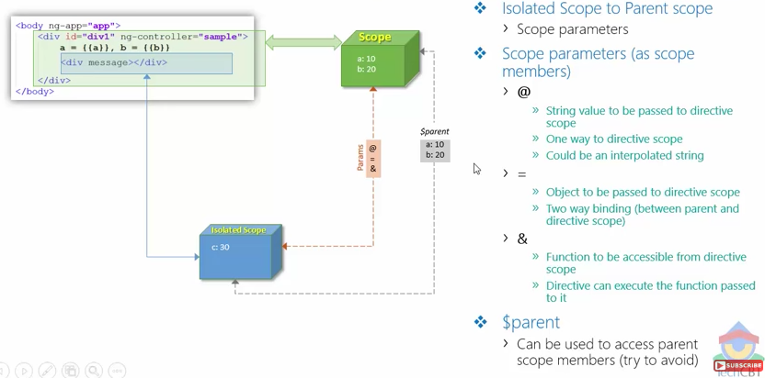

**isolated scope :** three way take parameter from parent and another way is also available $parent, we should avoid that, if you are not able to make happen by params way, then only we can use $parent to access parent data.

* if you have isolated, parent id will be different.

Ex for isoalated scope for @ pram

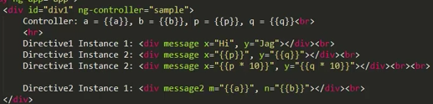

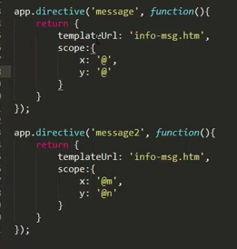

If you any text after @ that should match attribute in DOM ex. Here m and n.

*‘=’ isolated param have capability to do two way binding*

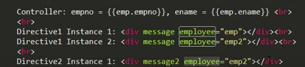

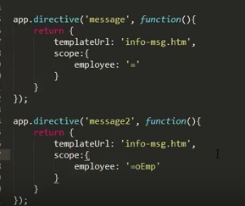

**Transclution getting started**

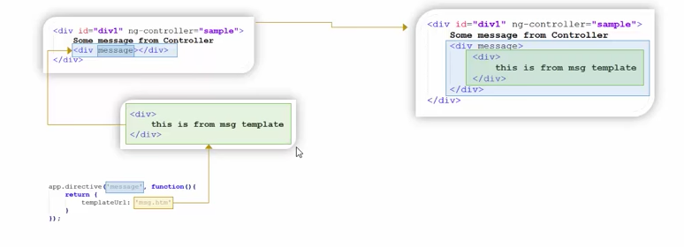

if we have content inside of DOM or in DIV and using same place directive , current content will be replaced with directive template.

If you see below red color highlighted stuff is missing.

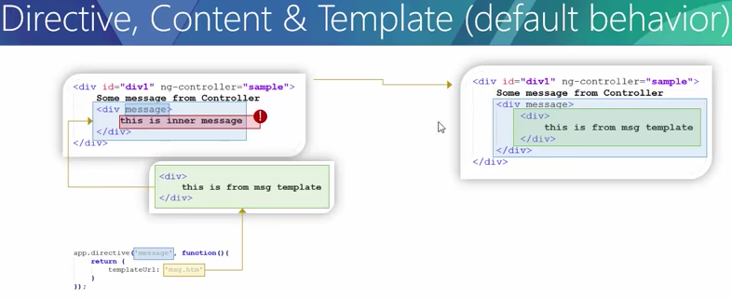

Ex. of transclution :

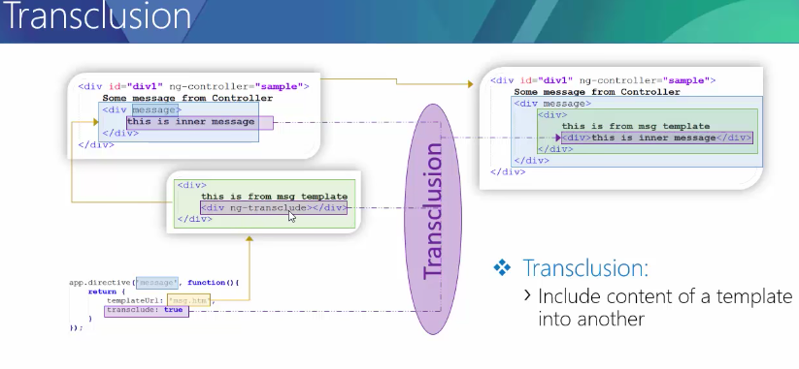

* transclude means whatever current content are exist in DOM , extract that content and insert directive content in it.
* Ans also ng-transcludue needs to be added in to html template.
* <div ng-transclude></div> this line of code decide to be where extorted code needs to put from parent.

**There are couple of ways to do transclude**

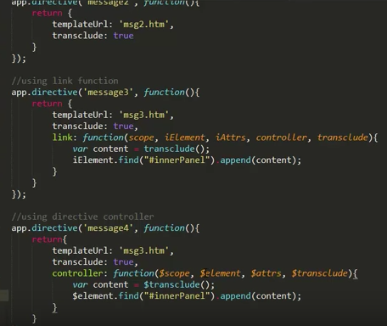

* if we use <ng-transclude> in the tag then just need to translcude:true in directive and it will take care
* another way to write id in div and with the help of id we can find the id we can place ransclude() functioan’s retrieved extracted html place into right by link function.
* the same stuff you can do by directive controller.

We can own my-transclude directive

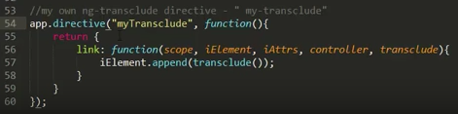

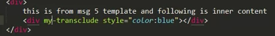

Transclude in depth

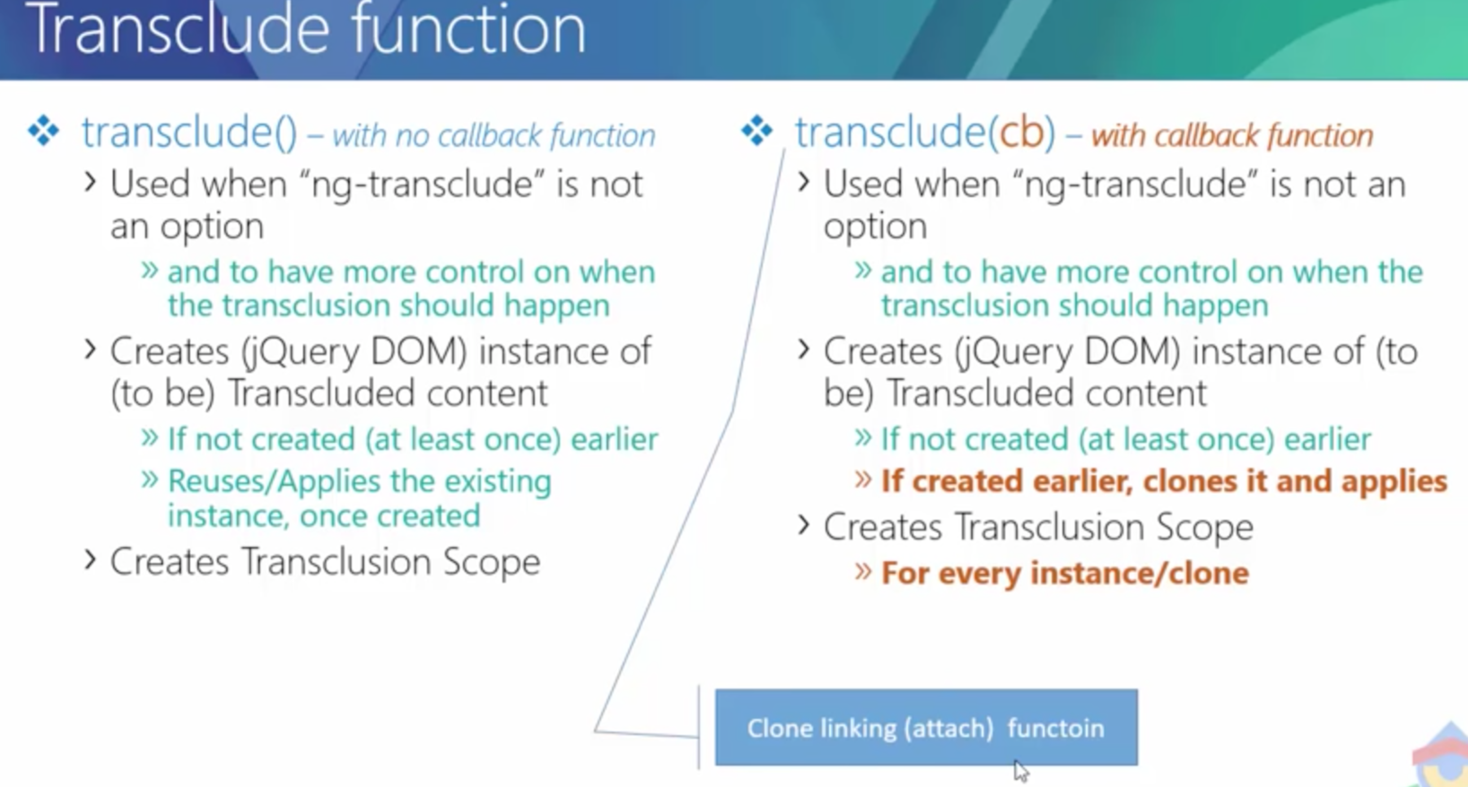

transclution in multiple location from parent :

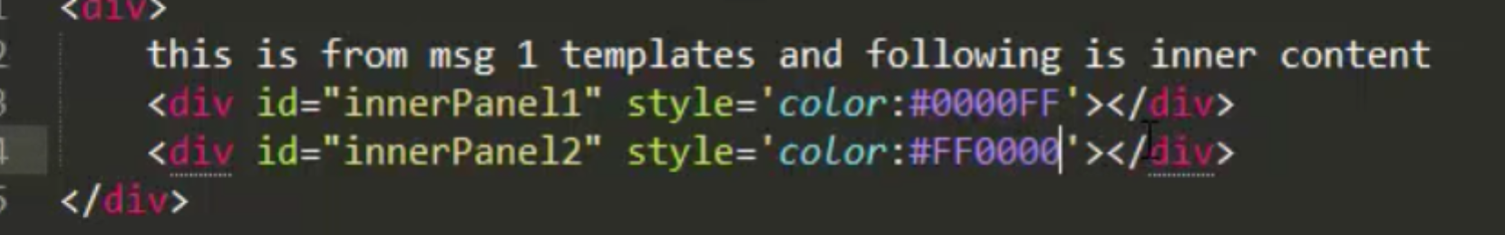

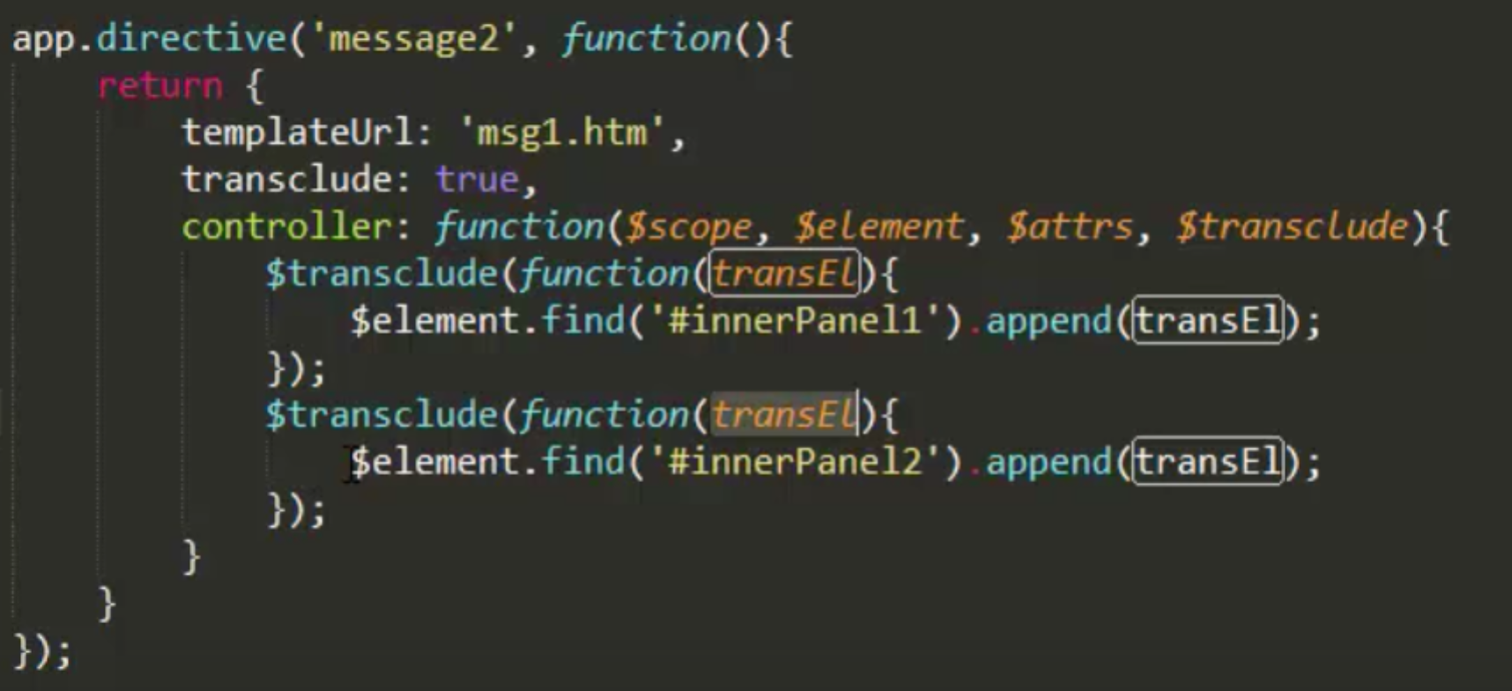

* whenever it is trying to transclution, it is taking inner html and cloning for another instance for next call of transclude() function. And that can be done transclude (cb) ,that mean putting callback into $transclude function.
* That’s called cloned linking function.